Draft Blog or Newsletter Language – Audience: Advocacy and Grassroots
Free Materials to Encourage Your Patients to Get Flu Vaccines
Help us increase access to flu vaccinations! Our organization is partnering with the Centers for Medicare & Medicaid Services (CMS) to promote flu vaccinations. We hope the following resources can support your efforts to encourage flu prevention with your clients and caregivers. CMS has asked our organization to storm social media and email listservs to promote flu vaccines on or around December 6 using the hashtag #FightFlu! Draft posts, tweets, and client-facing emails are available for you to customize, as well as additional translated resources below!
As a trusted voice your community, you can play a central role in ensuring members know they may be at high risk of complications if they get the flu. California is linguistically diverse and a new free resource from Cal MediConnect aims to help you reach your non-English speaking members. The CalDuals website provides a menu of free materials including a postcard translated into 11 languages including Arabic, Armenian, Cambodian, Chinese (simplified), Farsi, Hmong, Korean, Russian, Spanish, Tagalog, and Vietnamese. View all the materials by visiting http://calduals.org/learn-more-resources/flu-vaccine-campaign/.
If you are willing to help share this information in emails or social media posts, CMS wants to note your participation. Please let Lydia.Orth@cms.hhs.gov know if you can participate in any way.
Do you have success stories of promoting public health interventions with community members who are non-English speaking? Best practices for sharing annual flu vaccinations information with beneficiaries? CMS wants to hear from you!
Share your story! (Link to survey: https://goo.gl/forms/xLjoSJ5bk3MogJqF3)

Draft Tweets
- Spread the word about FREE advertisements in multiple languages to promote annual vax in your clinic http://calduals.org/learn-more-resources/flu-vaccine-campaign/ #FightFlu # CalMediConnect
- Get a #flu vaccine to help protect yourself from flu http://calduals.org/learn-more-resources/flu-vaccine-campaign/ #FightFlu # CalMediConnect
- Be Strong and get vaccinated! http://calduals.org/learn-more-resources/flu-vaccine-campaign/ #FightFlu # CalMediConnect
- Protecting yourself from #flu also protects the people around you http://calduals.org/learn-more-resources/flu-vaccine-campaign/ #FightFlu # CalMediConnect
- #FightFlu this season: Be strong and get a flu shot http://calduals.org/learn-more-resources/flu-vaccine-campaign/ #FightFlu # CalMediConnect

Draft Facebook Posts

Upload a copy of a translated postcard to your clinic’s Facebook page and include #FightFlu #CalMediConnect

Get free translated materials promoting the importance of an annual flu vaccination by visiting http://calduals.org/learn-more-resources/flu-vaccine-campaign/ #FightFlu # CalMediConnect

Arabic
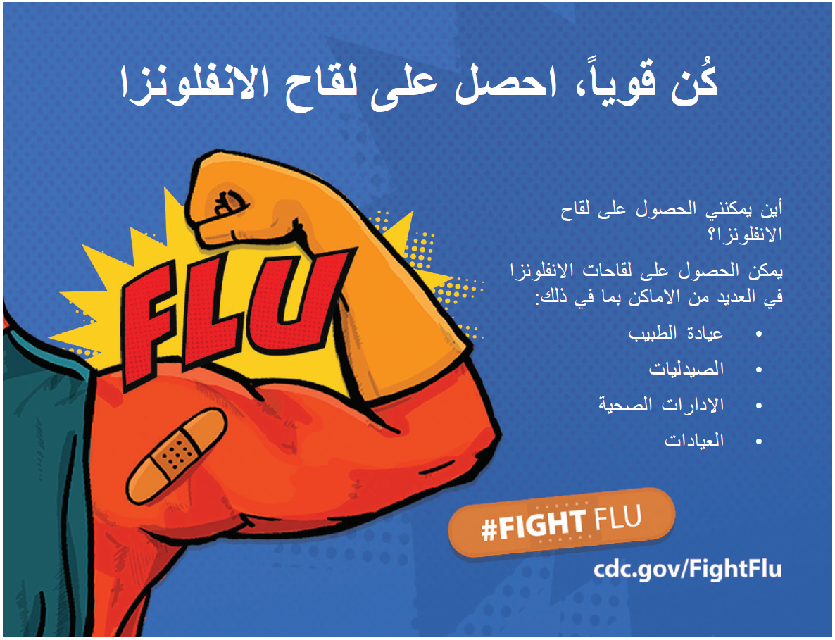

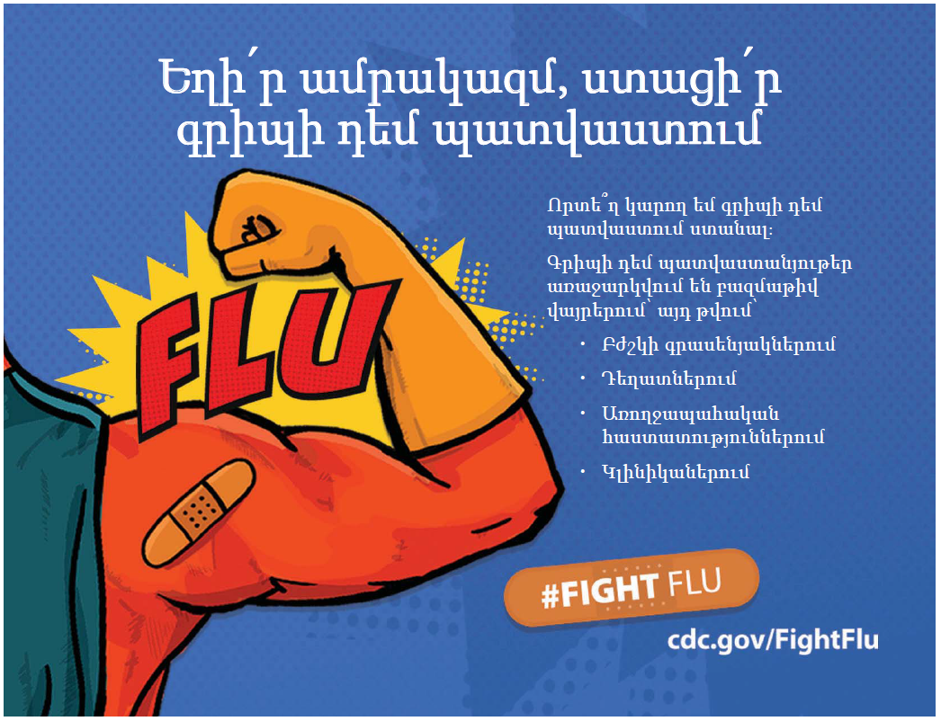
Armenian

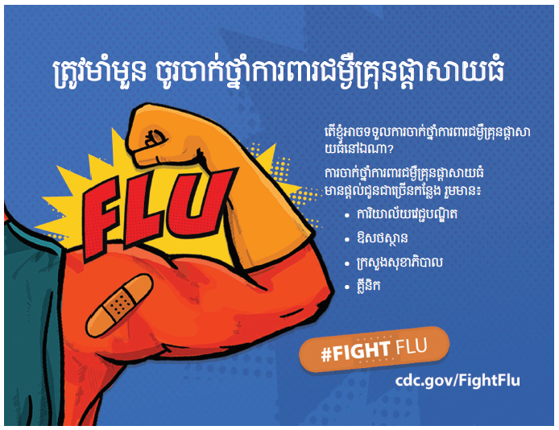
Cambodian

Chinese
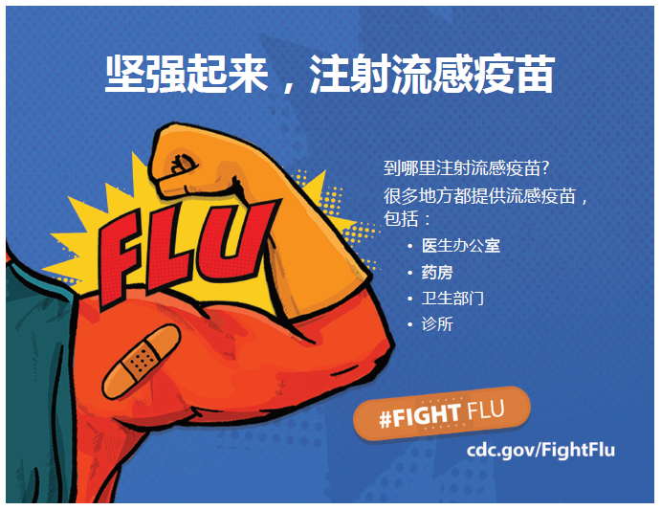

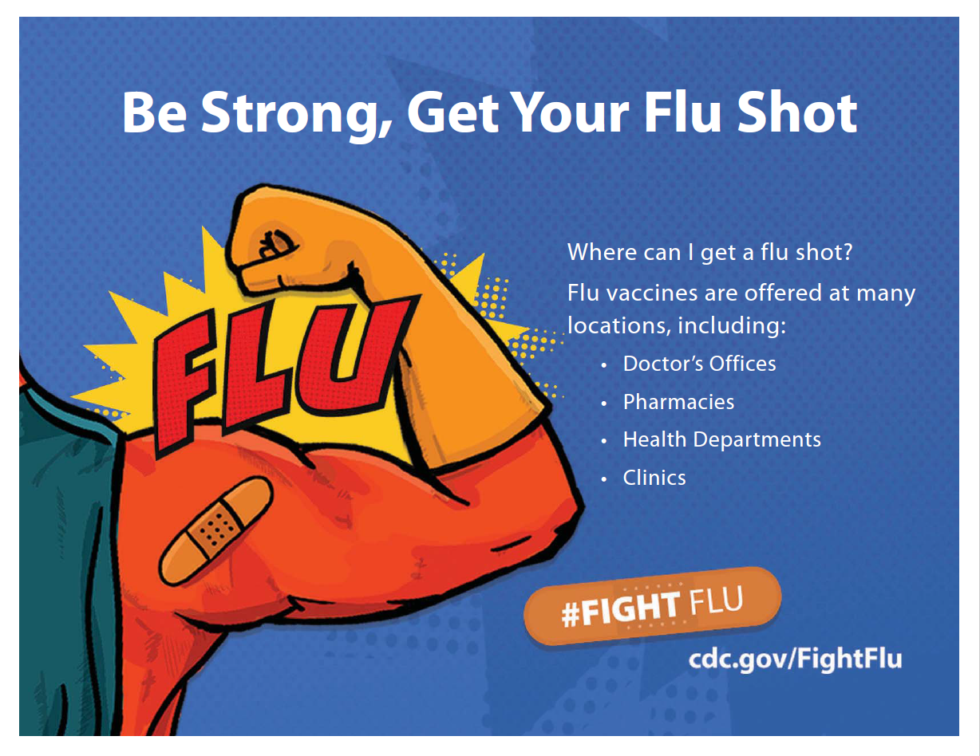
English

Farsi
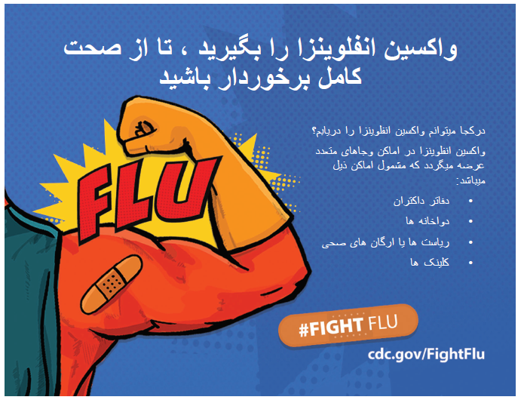

Hmong
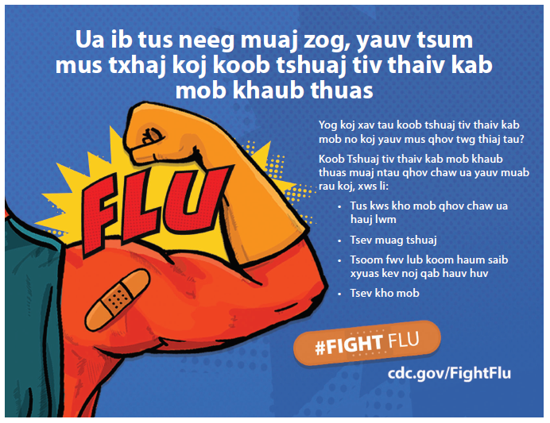

Korean
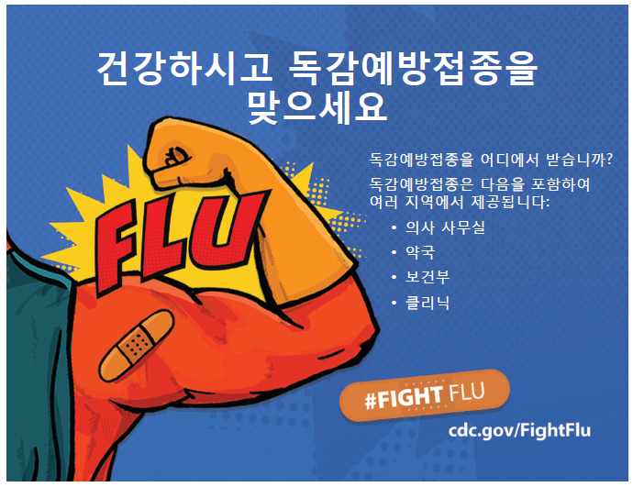

Russian
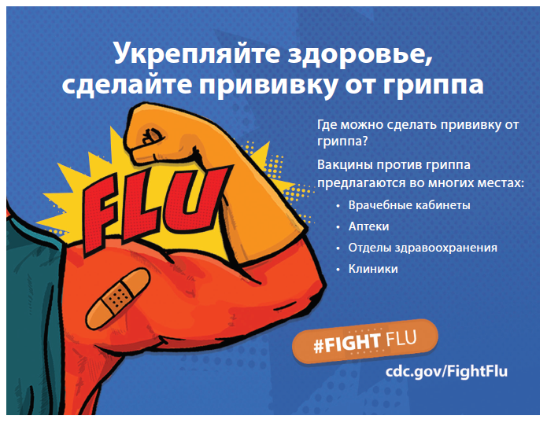

Spanish
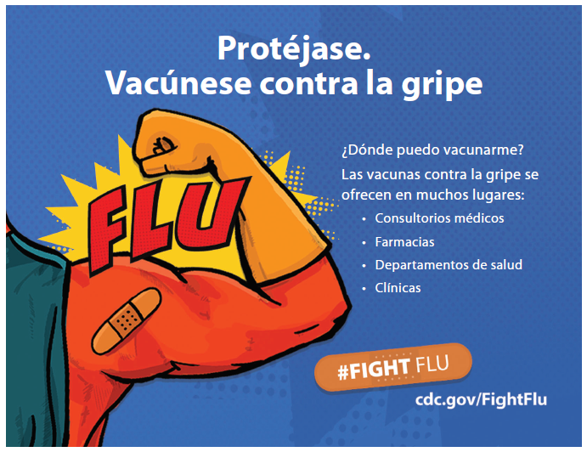

Tagalog
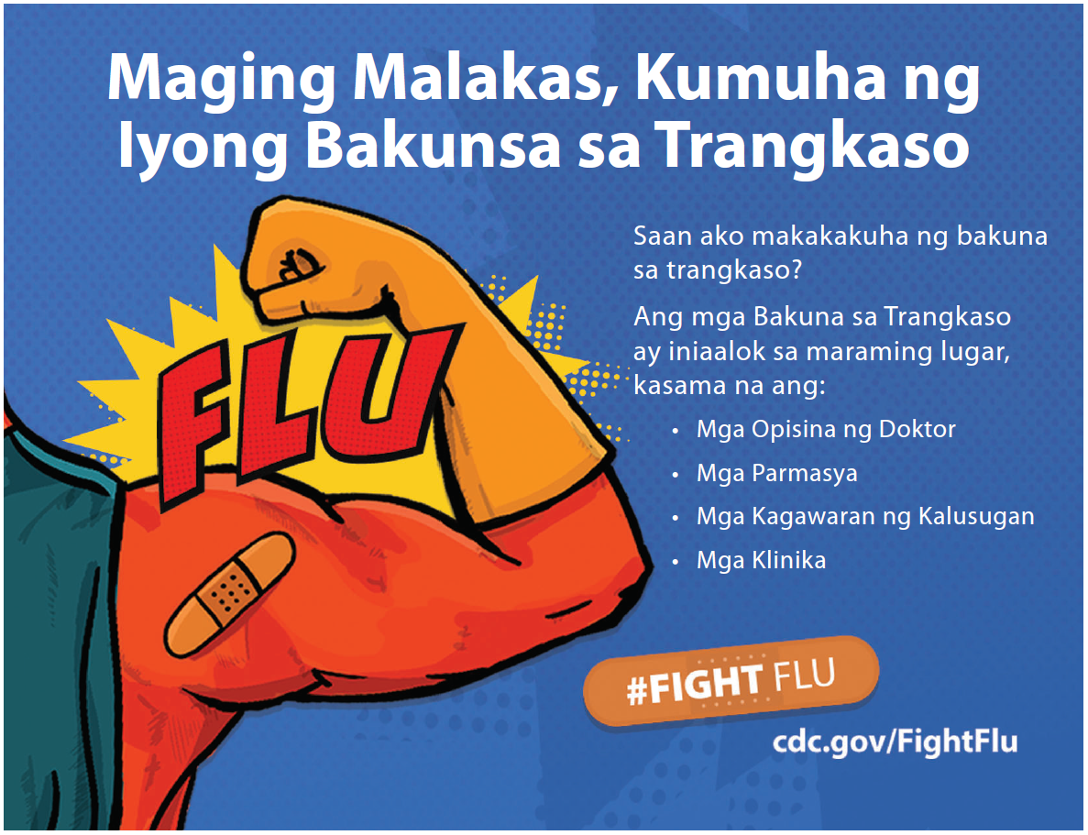

Vietnamese
