Draft Blog or Newsletter Language – Audience: LTSS providers
Free Materials to Encourage Your Patients to Get Flu Vaccines
Help us increase access to flu vaccinations! Our organization is partnering with the Centers for Medicare & Medicaid Services (CMS) to promote flu vaccinations. We hope the following resources can support your efforts to encourage flu prevention with your clients and caregivers. CMS has asked our organization to storm social media and email listservs to promote flu vaccines on or around December 6 using the hashtag #FightFlu! Draft Facebook posts, tweets, and client-facing emails are available for you to customize, as well as additional translated resources below!
As a provider in your community, you can play a central role in ensuring your patients know they may be at high risk of complications if they get the flu. California is linguistically diverse and a new free resource from Cal MediConnect aims to help you reach your non-English speaking clients. The CalDuals website provides a menu of free materials including a postcard advertisement translated into 11 languages including Arabic, Armenian, Cambodian, Chinese (simplified), Farsi, Hmong, Korean, Russian, Spanish, Tagalog, and Vietnamese. View all the materials by visiting http://calduals.org/learn-more-resources/flu-vaccine-campaign/.
If you are willing to share this information in emails or social media posts, CMS wants to note your participation. Please let Lydia.Orth@cms.hhs.gov know if you can participate in any way.
Do you have success stories of promoting public health interventions with clients who are non-English speaking? Best practices for sharing annual flu vaccinations information with beneficiaries? CMS wants to hear from you!
Share your story! (Link to survey: https://goo.gl/forms/xLjoSJ5bk3MogJqF3)

Draft Blog or Newsletter Language – Audience: Clinicians/Provider practices
Free Materials to Encourage Your Patients to Get Flu Vaccines
Help us increase access to flu vaccinations! Our organization is partnering with the Centers for Medicare & Medicaid services to promote flu vaccinations. We hope the following resources can support your efforts to encourage flu prevention with your patients. CMS has asked our organization to storm social media and email listservs to promote flu vaccines on or around December 6 using the hashtag #FightFlu! Draft Facebook posts, tweets, and client-facing emails are available for you to customize, as well as additional translated resources below!
As a health care provider in your community, you can play a central role in ensuring your patients know they may be at high risk of complications if they get the flu. California is linguistically diverse, and a new free resource from Cal MediConnect aims to help you reach your non-English speaking clients. A CalDuals webpage provides a menu of free materials including a postcard advertisement translated into 11 languages including Arabic, Armenian, Cambodian, Chinese (simplified), Farsi, Hmong, Korean, Russian, Spanish, Tagalog, and Vietnamese. View all the materials by visiting http://calduals.org/learn-more-resources/flu-vaccine-campaign/.
If you are willing to join CMS and our organization in any emails or social media posts, CMS wants to note your participation. Please let Lydia.Orth@cms.hhs.gov know if you can participate in any way.
Do you have success stories of reaching patients who are non-English speaking? Best practices for sharing annual flu vaccinations information with beneficiaries? CMS wants to hear from you!
Share your story! (Link to survey: https://goo.gl/forms/xLjoSJ5bk3MogJqF3)

Draft Tweets
- Spread the word about FREE advertisements in multiple languages to promote annual vax in your clinic http://calduals.org/learn-more-resources/flu-vaccine-campaign/ #FightFlu # CalMediConnect
- Providers are trusted sources of health info - promote flu vax http://calduals.org/learn-more-resources/flu-vaccine-campaign/ #FightFlu # CalMediConnect
- Providers rec for a yearly #flu vax is important to patients http://calduals.org/learn-more-resources/flu-vaccine-campaign/ #FightFlu # CalMediConnect
- Get a #flu vaccine to help protect yourself from flu http://calduals.org/learn-more-resources/flu-vaccine-campaign/ #FightFlu # CalMediConnect
- Be Strong and get vaccinated! http://calduals.org/learn-more-resources/flu-vaccine-campaign/ #FightFlu # CalMediConnect

Draft Facebook Posts

Upload a copy of a translated postcard to your clinic’s Facebook page and include #FightFlu #CalMediConnect

Get free translated materials promoting the importance of an annual flu vaccination by visiting http://calduals.org/learn-more-resources/flu-vaccine-campaign/ #FightFlu # CalMediConnect

Arabic
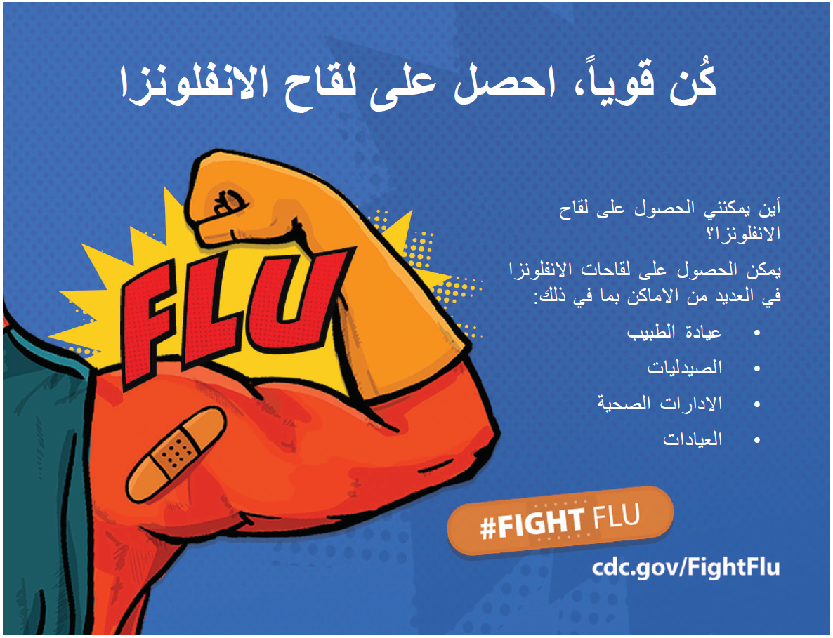

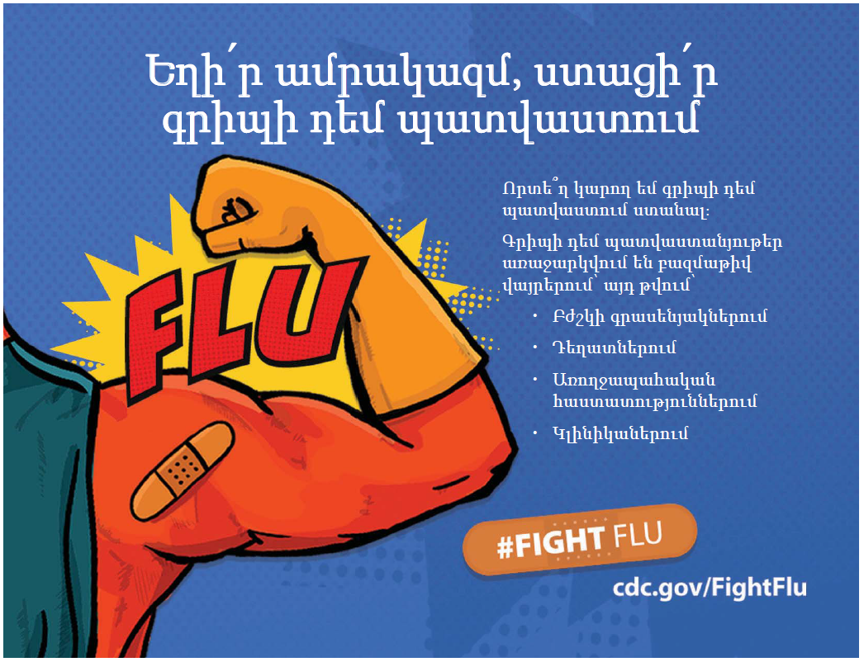
Armenian

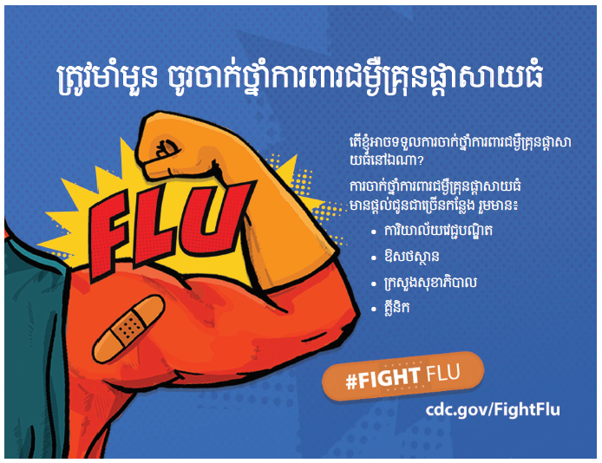
Cambodian

Chinese

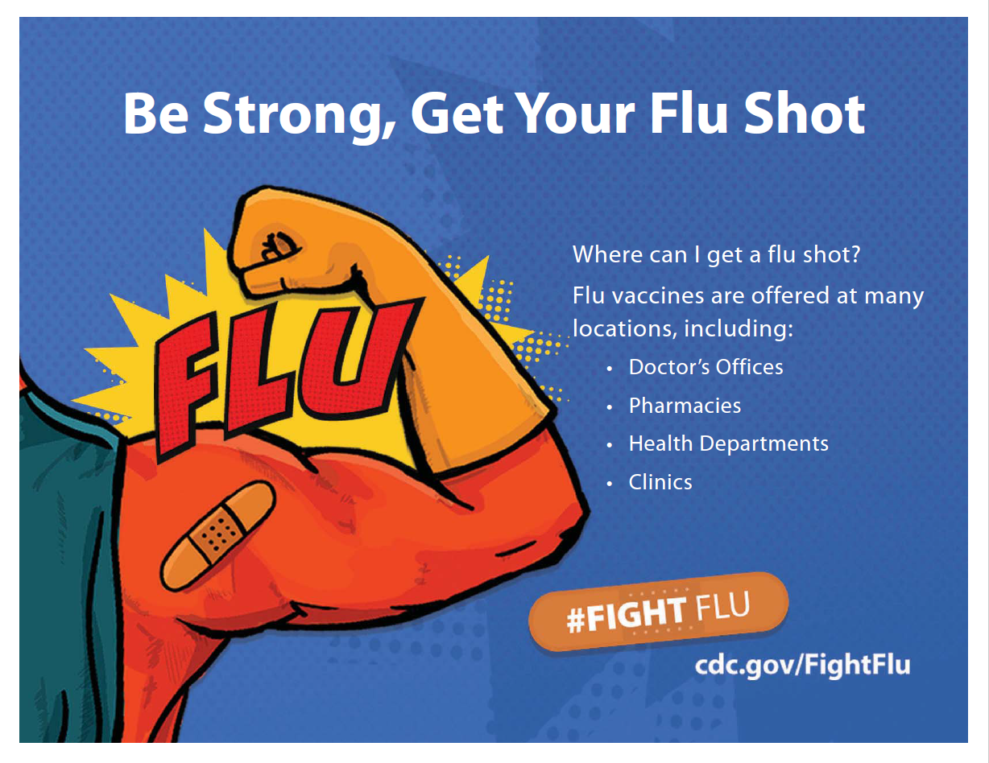
English

Farsi

Hmong
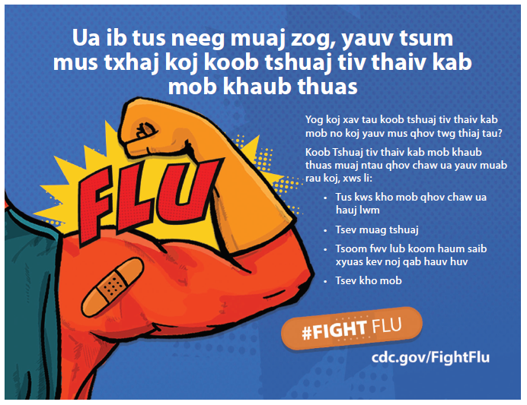

Korean
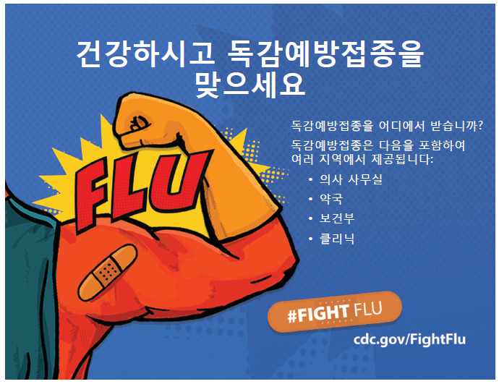

Russian
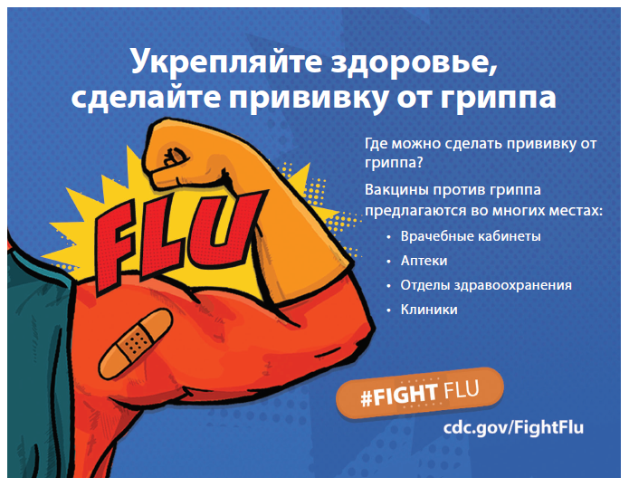

Spanish
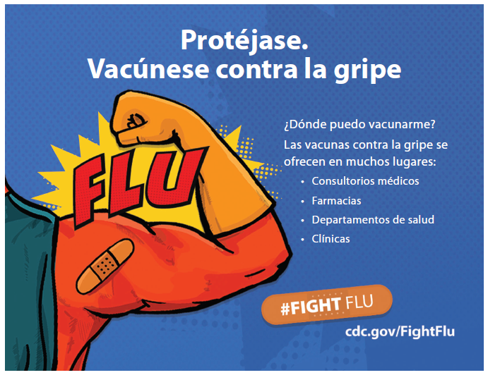

Tagalog
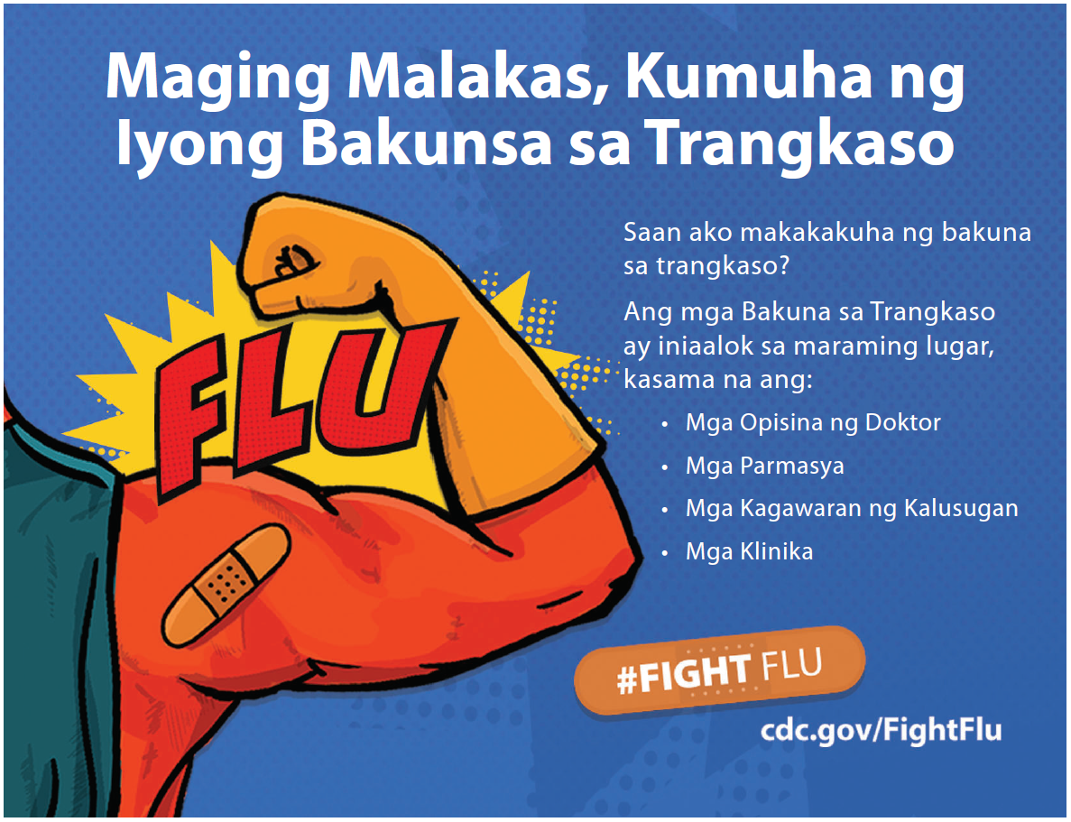

Vietnamese
